1. The time dependent equation for radial diffusion from a capillary is

|  |  |  |
| --- | --- | --- |
| **Prob #** | **Points** | **Max** |
| **1a** |  | **20** |
| **1b** |  | **10** |
| **2a** |  | **15** |
| **2b** |  | **20** |
| **2c** |  | **15** |
| **2d** |  | **10** |
| **3** |  | **10** |
| **Total** |  | **100** |

$$\frac{∂C}{∂t}=D_{AB}\frac{1}{r}\frac{∂}{∂r}\left(r\frac{∂C}{∂r}\right)$$

1. Use separation of variables, with $C\left(r,t\right)=R\left(r\right)T\left(t\right)$ to obtain two ordinary differential equations, one for $R(r)$ and one for $T\left(t\right)$. (Use $-λ^{2}$ as the constant.)

**Answer:**

$$\frac{∂RT}{∂t}=D_{AB}\frac{1}{r}\frac{∂}{∂r}\left(r\frac{∂RT}{∂r}\right)$$

Because $R$ is not a function of $t$ and $T$ is not a function of $r$.

$$R\frac{∂T}{∂t}=D_{AB}T\frac{1}{r}\frac{∂}{∂r}\left(r\frac{∂R}{∂r}\right)$$

Divide by $RT$

$$\frac{1}{T}\frac{∂T}{∂t}=D_{AB}\frac{1}{R}\frac{1}{r}\frac{∂}{∂r}\left(r\frac{∂R}{∂r}\right)$$

The left hand side is a function of $t$ only, and the right hand side is a function of $r$ only, so they must be equal to the same constant.

$$\frac{1}{T}\frac{∂T}{∂t}=D_{AB}\frac{1}{R}\frac{1}{r}\frac{∂}{∂r}\left(r\frac{∂R}{∂r}\right)={-λ}^{2}$$

$$\frac{dT}{dt}+λ^{2}T=0$$

$$D_{AB}\frac{1}{r}\frac{d}{dr}\left(r\frac{dR}{dr}\right)+λ^{2}R=0$$

1. Deduce the solution to one of the resulting equations. (Hint: You have seen the solution to one of the equations, but may not yet know the solution to the other.)

**Answer:**

For the time dependence, the solution is

$$T=Ae^{-λ^{2}t}$$

1. A hollow fiber has a diameter of 200 $μ$ m and a length of 10 cm. The nominal molecular weight cutoff for the pores (NMWCO) is 50,000 g/mole.
2. What is the pore radius in cm?

**Answer:**

We can approximate the pore radius as the molecular radius of the largest molecule that will pass through the walls.

$$a={\left(\frac{3MW}{4πρN_{A}}\right)}^{\frac{1}{3}}$$

$$a={\left(\frac{\left(3\right)\left(50,000\right)}{4π\left(1\frac{g}{cm^{3}}\right)\left(6.023×{10}^{23}\right)}\right)}^{\frac{1}{3}}=2.71×{10}^{-7} \text{cm}$$

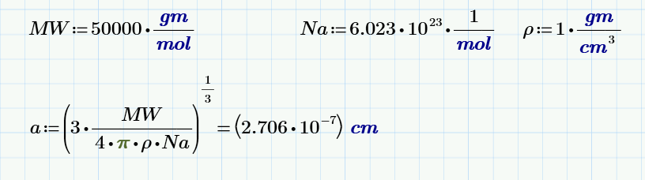

1. Find the actual sieving coefficient of a solute of molecular radius of $5×{10}^{-8}$ cm for a fiber of this length and radius, but with a pore radius of $1×{10}^{-7}$ cm.

**Answer:**

$$S_{a}={\left(1-\frac{a}{r}\right)}^{2}\left[2-{\left(1-\frac{a}{r}\right)}^{2}\right]\left[1-\frac{2}{3}{\left(\frac{a}{r}\right)}^{2}-0.163{\left(\frac{a}{r}\right)}^{3}\right]$$

where

$$\frac{a}{r}=\frac{5×{10}^{-8}}{1×{10}^{-7}}=0.5$$

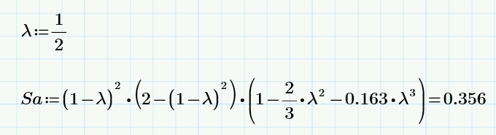

1. For the same fiber in Part b, find the total plasma flux, $J$, assuming that the osmotic pressure is negligible and that the mechanical pressure across the wall is 10,000 Pa. Assume that $ϵ=A_{p}/S=0.2$, $μ_{plasma}=0.01 g/(cm-s)$, pore tortuosity is 1, and the hollow fiber wall thickness is 50 $μ$ m.

**Answer:**

$$J=L_{p}S\left[\left(P_{c}-P_{IF}\right)-\left(π_{c}-π_{IF}\right)\right]=L_{p}SΔ\overline{P}$$

where

$$L_{p}=\frac{A_{p}}{S}\frac{R^{2}}{8μτt_{m}}=5×{10}^{-11}\frac{{\text{cm}}^{2}\text{s}}{\text{g}}$$

$$L_{p}SΔ\overline{P}=3.142×{10}^{-7}\frac{{\text{cm}}^{3}}{\text{s}}$$

MathCad gives

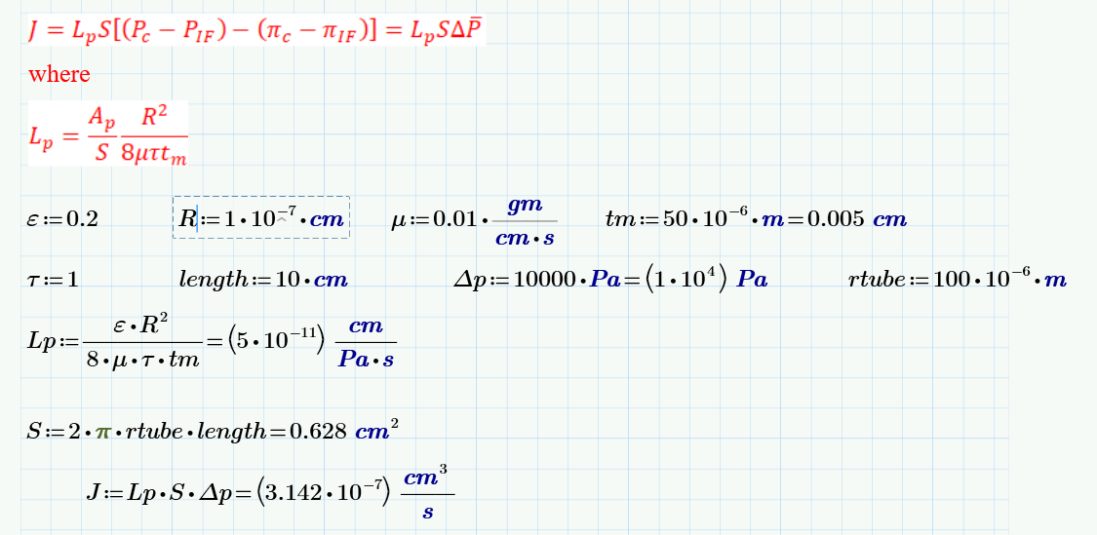

1. Find the filtrate concentration of a hypothetical molecule in this fiber if the actual sieving coefficient is 0.3, the solvent flux per unit area is ${10}^{-4}$ cm/s, the mass transfer coefficient is $2×{10}^{-4}$ cm/s. Assume that the concentration of this drug is 0.02 M in the bulk solution.

**Answer:**

$$S_{0}≡\frac{C_{filtrate}}{C_{bulk}}=\frac{S_{a}}{\left(1-S_{a}\right)e^{- \frac{q}{k_{m}}}+S_{a}}=\frac{0.3}{\left(1-0.3\right)e^{- \frac{{10}^{- 4} \frac{cm}{s}}{2×{10}^{- 4} \frac{cm}{s}}}+0.3}=0.414$$

$$C_{\text{filtrate}}=C_{\text{bulk}}S_{0}=\left(0.02\frac{\text{moles}}{\text{liter}}\right)\left(0.206\right)=0.00828 \text{M}$$

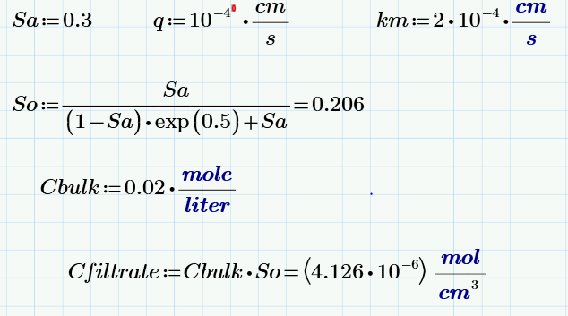

1. For oxygen diffusion into a spherical tissue, determine what condition must be met such that the oxygen concentration goes to zero at exactly the center of the sphere and the depletion of oxygen as a result of diffusion within the sphere is equal to the depletion of oxygen as a result of the mass transfer coefficient.

**Answer:**

The equation for the sphere is

$$pO_{2}=pO_{2,bulk}-\frac{HϕΓ_{max}R}{3k_{m}}-\frac{HϕΓ_{max}R^{2}}{6D_{T}}\left(1-{\left(\frac{r}{R}\right)}^{2}\right)$$

At the sphere center it is

$$pO_{2}=pO_{2,bulk}-\frac{HϕΓ_{max}R}{3k_{m}}-\frac{HϕΓ_{max}R^{2}}{6D_{T}}$$

For this to be zero at the center of the sphere, we need

$$pO_{2,bulk}=\frac{ϕΓ_{max}R}{3k_{m}}+\frac{ϕΓ_{max}R^{2}}{6D_{T}}$$

We can also write this in terms of the Damkholer number

$$pO_{2,bulk}=\text{Da}O_{2, bulk}\left(\frac{1}{3\text{Sh}}+\frac{1}{6}\right)$$

If the effect of diffusion within the sphere is the same as the effect of the mass transfer coefficient

$$\frac{HϕΓ_{max}R}{3k_{m}}=\frac{HϕΓ_{max}R^{2}}{6D_{T}}$$

Or

$$\frac{1}{k_{m}}=\frac{R}{2D_{T}}$$

$$\frac{k_{m}R}{D_{T}}=2$$

**Potentially Useful Formulas**

# Solute Flux

$$Π=RTC_{s} \text{van't Hoff's law}$$

$$J=L_{p}S\left[\left(P_{c}-P_{IF}\right)-\left(π_{c}-π_{IF}\right)\right]=L_{p}SΔ\overline{P}$$

$$L_{p}=\frac{A_{p}}{S}\frac{R_{\text{pore}}^{2}}{8μτt_{m}}$$

$$ε=\frac{A_{p}}{S}$$

$$S_{a}={\left(1-\frac{a}{r}\right)}^{2}\left[2-{\left(1-\frac{a}{r}\right)}^{2}\right]\left[1-\frac{2}{3}{\left(\frac{a}{r}\right)}^{2}-0.163{\left(\frac{a}{r}\right)}^{3}\right]$$

$$S_{0}≡\frac{C_{filtrate}}{C_{bulk}}=\frac{S_{a}}{\left(1-S_{a}\right)e^{- \frac{q}{k_{m}}}+S_{a}} ,$$

# Nernst Equation

$$V=\frac{RT}{zF}\ln{\frac{C\text{outside}}{C\text{inside}}}$$

# Error Function

$$\operatorname{erf}\left(x\right)≡\frac{2}{\sqrt{π}}\int_{0}^{x}{e^{-η^{2}} ⅆη}$$

$$\operatorname{erfc}\left(x\right)=\left(1-\operatorname{erf}\left(x\right)\right)$$

# Differential Equations

|  |  |
| --- | --- |
| $$\frac{df}{dt}+αf=0$$ | $$f=A e^{-αt}$$ |
| Fourier Equation $$\frac{d^{2}f}{dt^{2}}+ α^{2}f=0$$ | $$f=c_{1}\cos\left(αt\right){+c}_{2}\sin\left(αt\right)$$ or $f=A_{1}{ e}^{i αt}+A_{2}e^{-iαt}$ |
| Similar to 4, but with negative linear term $$\frac{d^{2}f}{dt^{2}}- α^{2}f=0$$ | $$f=c_{1}\cosh\left(αt\right)+c_{2}\sinh\left(αt\right)$$ or $f=A_{1}{ e}^{ αt}+A_{2}e^{-αt}$ |

**Fick’s First Law of Diffusion**

$$j_{s}=-D_{AB}\frac{dC}{dy} \frac{\text{moles}}{{\text{cm}}^{2}\text{s}} \text{Where} j_{s} \text{is solute flux} \text{per unit area}$$

$$D_{AB}(\text{in cm}\text{2}\text{/sec)}=1.013×{10}^{-4}{\left(MW\right)}^{-0.46} \text{Empirical Model}$$

$$D_{AB}=\frac{RT}{6πμaN_{a}} \text{Stokes-Einstein}$$

$$a={\left(\frac{3MW}{4πρN_{A}}\right)}^{\frac{1}{3}} \text{Molecular Radius}$$

$${\left.j_{s}\right|}_{\text{surface}}=k_{m}\left(C_{\text{high}}-C_{\text{low}}\right) \text{Definition of mass transfer coefficient}$$

# Non-Dimensional Parameters

Let $V$ be a characteristic velocity, $d$ be a characteristic length, $ν$ be kinematic viscosity,

$$Re_{d}≡\frac{Vd}{ν} \text{Reynolds number}$$

Further, let $D$ be diffusion coefficient.

$$Sc≡\frac{μ}{ρD_{AB}}=\frac{ν}{D_{AB}} \text{Schmidt number}$$

Let $k_{m}$ be the mass transfer coefficient.

$$Sh_{x}≡\frac{k_{m}x}{D_{AB}} \text{Sherwood number}$$

$$\text{Pe}=\frac{Vd}{D_{AB}} \text{Peclet number}$$

$$\text{Da}=\frac{ϕΓδ^{2}}{D_{T}C_{\text{oxygen}}^{\text{in}}} \text{Damkholer number}$$

# General Mass Transport Equation (Fick’s Second Law)

$$\frac{∂C}{∂t}+v⋅∇C=D∇^{2}C+R_{a}$$

In Cardesian coordinates

$$\frac{∂C}{∂t}+v_{x}\frac{∂C}{∂x}+v_{y}\frac{∂C}{∂y}+v_{z}\frac{∂C}{∂z}=D\left(\frac{∂^{2}C}{∂x^{2}}+{\frac{∂^{2}C}{∂y}}^{2}+\frac{∂^{2}C}{∂z^{2}}\right)+R_{a}$$

In cylindrical coordinates

$$\frac{∂C}{∂t}+v_{r}\frac{∂C}{∂r}+\frac{v_{θ}}{r}\frac{∂C}{∂θ}+v_{z}\frac{∂C}{∂z}=D\left(\frac{1}{r}\frac{∂}{∂r}\left(r\frac{∂C}{∂r}\right)+\frac{1}{r^{2}}\frac{∂^{2}C}{∂θ^{2}}+\frac{∂^{2}C}{∂z^{2}}\right)+R_{a}$$

In spherical coordinages

$$\frac{∂C}{∂t}+v_{r}\frac{∂C}{∂r}+\frac{v_{θ}}{r}\frac{∂C}{∂θ}+\frac{v_{φ}}{r\sin{θ}}\frac{∂C}{∂φ}$$

$$=D\left(\frac{1}{r^{2}}\frac{∂}{∂r}\left(r^{2}\frac{∂C}{∂r}\right)+\frac{1}{r^{2}\sin{θ}}\frac{∂}{∂θ}\left(\sin{θ\frac{∂C}{∂θ}}\right) +\frac{1}{r^{2}\sin^{2}{θ}}\frac{∂^{2}C}{∂φ^{2}}\right)+R_{a}$$

# Boundary Layer Development

Pipe flow, fully developed momentum boundary layer $\frac{z}{d_{tube}}=0.05 \text{Re}$.

Pipe flow, fully developed concentration boundary layer $\frac{z}{d_{tube}}=0.05 \text{Re Sc}$.

Flat plate, laminar boundary layer $\text{Re}<300,000$.

Cylinder, laminar flow $\text{Re}<2,000$.

# Constants

Avagadro’s Number: $6.023 × {10}^{23} \text{atoms}/\text{mole}$

Faraday’s Constant: $F=2.3×{10}^{4} \frac{\text{cal g}}{\text{Volt mole}}$

Universal Gas Constant: $R=8.314\frac{Joule}{mole Kelvin}$

Centigrade to Kelvin: Degrees Kelvin $=$ 273.15 $+$ Degrees Centigrade

**Table of Laplace Transforms**

|  |  |  |
| --- | --- | --- |
| 1 |  | 1 |
| 2 |  |  |
| 3 |  |  |
| 4 |  |  |
| 5 |  |  |
| 6 |  |  |
| 7 |  |  |
| 8 |  |  |
| 9 |  |  |
| 10 |  |  |
| 11 |  |  |
| 12 |  |  |
| 23 | $$\frac{x}{2\sqrt{πat^{3}}}e^{- \frac{x^{2}}{4at}} u_{s}\left(t\right)$$ | $$e^{-\sqrt{\frac{s}{a}}x}$$ |
| 24 | $$\sqrt{\frac{a}{πt}} e^{- \frac{x^{2}}{4at}} u_{s}\left(t\right)$$ | $\sqrt{\frac{a}{s}}$ $e^{-\sqrt{\frac{s}{a}}x}$ |
| 25 | $$erfc\left(\frac{x}{2\sqrt{at}}\right)u_{s}\left(t\right)t)t(p l ordinatesfficient.$$ | $$\frac{e^{-\sqrt{\frac{s}{a}}x}}{s}$$ |
| 26 | $$\left[2\sqrt{\frac{at}{π}} e^{-\frac{x^{2}}{4at}}-x erfc\left(\frac{x}{2\sqrt{at}}\right)\right]u_{s}\left(t\right)t)t(p l ordinatesfficient.$$ | $$\frac{\sqrt{a}}{\sqrt{s^{3}}} e^{-\sqrt{\frac{s}{a}}x}$$ |
| 27 | $$\left[\left(t+\frac{x^{2}}{2a}\right)erfc\left(\frac{x}{2\sqrt{at}}\right)-x\sqrt{\frac{t}{πa}} e^{-\frac{x^{2}}{4at}}\right]u_{s}\left(t\right)$$ | $$\frac{1}{s^{2}}e^{-\sqrt{\frac{s}{a}}x}$$ |

# Sherwood Numbers

|  |  |
| --- | --- |
| Condition | Sh |
| Sphere in a stagnant fluid | 2 |
| Forced convection over a sphere | $$2+0.6{\text{Re}}^{\frac{1}{2}}{\text{Sc}}^{\frac{1}{3}}$$ |
| Laminar flow over a flat plate | $$0.646 {\text{Re}}^{\frac{1}{2}}{\text{Sc}}^{\frac{1}{3}}$$ |
| Laminar flow in a cylindrical tube, short contact time | $$1.615{\text{ Re}}^{\frac{1}{3}}{\text{Sc}}^{\frac{1}{3}}{\left(\frac{d_{tube}}{L}\right)}^{1/3}$$ |
| Laminar flow in a cylindrical tube, fully developed flow and concentration profiles | 3.66 |
| Turbulent flow through a circular tube | $$0.026 Re^{0.8}Sc^{\frac{1}{3}}$$ |
| Spinning Disk | $$0.62{\left(\frac{d_{\text{disk}}^{2}ω}{ν}\right)}^{\frac{1}{2}}{\text{Sc}}^{\frac{1}{3}}$$ |
| Falling Film, Average | $$1.38{\left(\frac{LV_{\text{film}}}{D_{AB}}\right)}^{\frac{1}{2}}$$ |

# Oxygen Concentrations

Henry’s Law

$$pO_{2}=C_{\text{oxygen}}H_{\text{oxygen}}$$

Sphere

$$pO_{2}=pO_{2,bulk}-\frac{HϕΓ_{max}R}{3k_{m}}-\frac{HϕΓ_{max}R^{2}}{6D_{T}}\left(1-{\left(\frac{r}{R}\right)}^{2}\right)$$

Planar Bioartificial Organ

$$pO_{2}=pO_{2}^{avg}-\frac{HδϕΓ}{P_{m}}+\frac{ΓHϕδ^{2}}{2D_{T}}\left({\left(\frac{x}{δ}\right)}^{2}-2\frac{x}{δ}\right)$$

Perfusion Bioreactor

$$θ\left(η\right)=1-\frac{\text{Da}}{{\text{Pe}}^{2}}\left(1-e^{-Pe\left(1- η\right)}\right)-\frac{\text{Da}}{\text{Pe}}η$$